C++ for Loop
In C++, the for loop is an entry-controlled loop that is mainly utilized to iterate a part of the program multiple times. If the number of iterations is fixed, it is recommended to use for loop than while or do-while loops.
Syntax:
The C++ for loop is the same as other languages, such as C and C#. We can initialize variables, check conditions, and increment/decrement values.
for(initialization; condition; update){
//code to be executed
}
- Initialization: It initializes the variables and is executed only once.
- Condition Statement: The condition statement checks the given condition. If the condition is true, it executes the of for loop. If the condition is false, it terminates the for loop.
- Update Expression: After execution of the loop body, this expression increments or decrements the loop variable by 1.
Flowchart of for Loop:
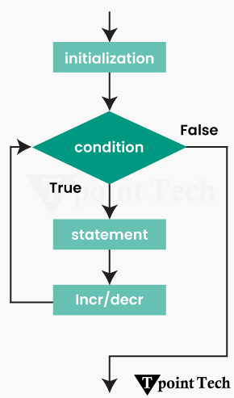
As we can see in the flowchart, use the following steps to implement the for loop in C++:
Step 1: First, go to the for loop and initialize the variables and their values.
Step 2: Next, the control flow jumps to the condition statement.
Step 3: Here, the condition is tested:
- If the condition is true, it executes the loop body.
- If the condition is false, it terminates the loop body and moves to the next iteration.
Step 4: After that, it goes to the update expression, where it increases or decreases the value by 1, and then again, it goes to step 3 to check the condition.
Step 5: At the end, it exits from the loop and prints the output.

Simple C++ for Loop Example:

Let us take a simple example to print the numbers 1 to 10 using the C++ for loop.
#include <iostream>
using namespace std; //using standard namespace
int main() //main function
{
for(int i=1;i<=10;i++) //code of C++ for loop
{
cout<<i <<"\n";
}
}
Output:
1
2
3
4
5
6
7
8
9
10
Factorial Program using C++ for Loop:
Let us take another example to find the factorial of a given number using a for loop in C++.
#include <iostream>
using namespace std; //using the standard namespace

// main code
int main() {
int n;
int fact = 1;

cout << "Enter a positive number: ";
cin >> n;

// for loop calculating factorial
for (int i = 1; i <= n; i++) {
fact = fact * i;
}

cout << "The factorial of " << n << " is: " << fact; //print the output

return 0;
}
Compiler
Output:
Enter a positive number: 6
The factorial of 6 is: 720
Multiplication table program using for loop in C++
Let us take an example to print a multiplication table using for loop in C++.
#include <iostream>
using namespace std; //using standard namespace

// main function
int main()
{

int n;
cout<<"Enter a Number: ";
cin >> n;

for (int i = 1; i <= 10; ++i) //for loop
cout << n << " * " << i << " = " << n * i << endl;
return 0;
}
Compiler
Output:
Enter a Number: 4
4 * 1 = 4
4 * 2 = 8
4 * 3 = 12
4 * 4 = 16
4 * 5 = 20
4 * 6 = 24
4 * 7 = 28
4 * 8 = 32
4 * 9 = 36
4 * 10 = 40
C++ Nested for Loop
In C++, if we have a for loop inside another for loop, it is known as a nested for loop. The inner loop is completely executed when the outer loop executes.
It allows us to perform complex iterations by executing a for loop for every iteration of the outer for loop. Nested for loops are beneficial when working with multi-dimensional arrays or patterns.
Syntax:
It has the following syntax:
for (initialization; condition; increment) {
for (initialization; condition; increment) {
// statement of inner loop
}
//statement of outer loop
}
Flowchart of Nested for loop:
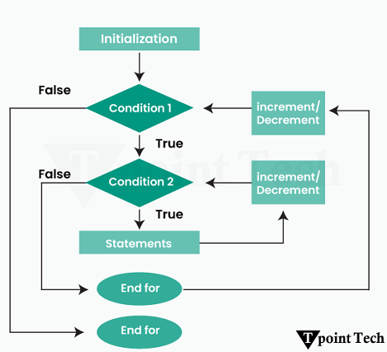

C++ Nested for Loop Example:
Let us take a simple example of a nested for loop in C++.
#include <iostream>
using namespace std; //using standard namespace

int main () //main function
{
for(int i=1;i<=3;i++) //outer for loop
{
for(int j=1;j<=3;j++) //inner for loop
{
cout<<i<<" "<<j<<"\n"; //print the value of i and j
}
}
}
Output:
1 1
1 2
1 3
2 1
2 2
2 3
3 1
3 2
3 3
C++ Pyramid Program using Nested for Loop:
Let us take an example to print a pyramid pattern using nested for loop in C++.
#include <iostream>
using namespace std;

// main function
int main()
{
int n;
cout << "Enter the Number of rows: ";
cin >> n;
// Outer loop to handle number of rows
for (int i = 0; i < n; i++) {

// Inner loop to handle number of columns
for (int j = 0; j <= i; j++) {

cout << "* "; // Printing stars
}

cout << endl; // moves to the new line after every row
}
}
Compiler
Output:
Enter the Number of rows: 6
*
* *
* * *
* * * *
* * * * *
* * * * * *
Explanation:
In this example, we have taken two for loops. Here, the first loop handles the number of rows, and the second loop handles the number of columns and prints the stars.
C++ Inverted Pyramid Program using Nested for Loop:
Let us take an example to print an inverted pyramid pattern using nested for loop in C++.
#include <iostream>
using namespace std;

// main function
int main()
{
int n;
cout << "Enter the Number of rows: ";
cin >> n;
// Outer loop to handle number of rows
for (int i = 0; i < n; i++) {

// Inner loop to handle number of columns
for (int j = n; j > i; j--) {

cout << "* "; // Printing stars
}

cout << endl; // moves to the new line after every row
}
}
Compiler
Output:
Enter the Number of rows: 5
* * * * *
* * * *
* * *
* *
*
Explanation:
In this example, we have taken two for loops. Here, the outer loop handles the number of rows, and the inner loop handles the number of stars per row.
C++ foreach Loop
The foreach loop is also known as the range-based for loop. It is mainly utilized to iterate over the elements of a container (such as list, array, vector, etc) in a simple way without performing initialization, increment/decrement, and testing. The ‘for’ keyword is utilized for the foreach loop in C++.
Syntax:
It has the following syntax:
for (data_type variable_name : container_name) {
// code to be executed
}
In this syntax,
- Variable_name: It is a variable name that is provided to the elements stored in a container.
- Container_name: It is a variable name of a container of any type, including list, array, vector, and many others.
C++ Foreach Loop Example:
Let us take an example to illustrate the foreach loop in C++.
#include <iostream>
#include <vector> //vector library
using namespace std; //using standard namespace

int main() //main function
{
vector<int> numbers = {15, 20, 25, 30, 35};

// Range-based for loop to modify each element
for (int& num : numbers) {
num += 5; // add 5 for each number
}

for (int num : numbers) {
cout << num << " "; //prints the output
}
cout << endl;

return 0;
}
Compiler
Output:
20 25 30 35 40
Explanation:
In this example, we have taken a vector library for using dynamic arrays. Next, we declare a vector of integers. After that, we use two for loops in this program. The first loop uses a reference to modify the vector elements, and the second loop prints the modified values.
C++ Infinite for Loop
In C++, if we remove the initialization, condition, and update expression, it will result in an infinite loop.
In other words, if we use a double semicolon in the for loop, it will be executed infinite times.
Syntax:
It has the following syntax:
for (; ; ){
//code to be executed
}
C++ Infinite For Loop Example:
Let us take an example to illustrate the infinite for loop in C++.
#include <iostream>
using namespace std;

int main () //main function
{
for (; ;) //infinite for loop
{
cout<<"Hello! Tpointtech"; //prints the output
}
}
Compiler
Output:
Hello! Tpointtech
Hello! Tpointtech
Hello! Tpointtech
Hello! Tpointtech
Here, we need to press Ctrl+C to exit from the infinitive program.
C++ for Loop MCQs
- In for loop, which of the following operators is utilized to separate expressions in C++?
- Colon (:)
- Semicolon (;)
- Ampersand (&)
- Comma (,)
Answer: (b) Semicolon (;)
- Which of the following options is the first expression of for loop in C++?
- Condition
- Increment/decrement
- Initialization
- None of the above
Answer: (c) Initialization
- What will be the output of the following code?
int main() {
for (int i = 1; i <= 5; i++) {
cout << i << " ";
}
return 0;
}
- 1 2 3 4 5
- 1 2 3 4 5 6
- 1 2 3 4
- 0 1 2 3 4 5
Answer: (a) 1 2 3 4 5
- What type of loop is the for loop in C++ programming?
- Exit-controlled loop
- Recursive loop
- Infinite loop
- Entry-controlled loop
Answer: (d) Entry-controlled loop
- Can we utilize the multiple initialization and update expression in a for loop in C++?
- Yes
- Only in C
- No
- Only in while loops
Answer: (a) Yes

